Gap Analysis:
Managing and Mitigating Conflict in Health-care Teams,
September 2012
Work Sheet

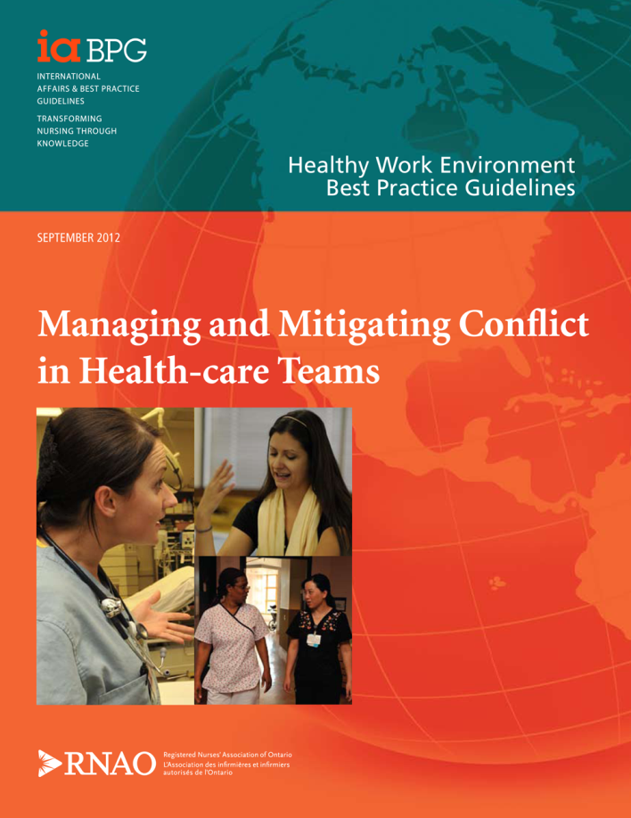

This guideline can be downloaded for free at:
http://rnao.ca/bpg/guidelines/managing-conflict-healthcare-teams

The RNAO Toolkit: Implementation of Best Practice Guidelines, Second Edition is also available at:
http://rnao.ca/bpg/resources/toolkit-implementation-best-practice-guidelines-second-edition

Date Completed:
Team Members participating in the Gap Analysis:

RNAO Healthy Work Environment Best Practice Guideline Recommendations | Met | Partially Met | Unmet | Notes  (Examples of what to include: is this a priority to our home, information on current practice, possible overlap with other programs or partners)
1.0 Organization Recommendations
1.1 Organizations identify and take action to prevent/mitigate factors contributing to conflict, for example:
- effects of shift work;
- team composition and size;
- workload and staffing;
- manager span of control;
- level of staff involvement in decision-making and provision of care;
- resource allocation;
- diversity in the workplace; and
- physical space.
1.2 Organizations support the systems and processes that minimize conflict, promote team functioning, value diversity and enact a culture of inclusiveness. Common attributes that exist between and among Health-care professionals include:
- educational background;
- work values;
- ethnicity and culture;
- age;
- roles and responsibilities;
- power;
- scope of practice; and
- gender.
1.3 Organizations implement a regular assessment, which may include quality indicators, to identify the types and outcomes (short-and long-term) of conflict among nurses, physicians and other Health-care professionals. Assessment data is used to develop and implement both action and communication plans for the organization.
1.4 Organizations implement and sustain evidence-based strategies that support/enable leaders to foster self-awareness, possess emotional intelligence, competencies and utilize conflict management principles.
1.5 Organizations ensure all employees, physicians, and volunteers have the knowledge and competencies related to conflict management by:
- Providing ongoing mandatory skills-based education regarding cooperative or active style of managing and mitigating conflict, clear communication, effective team building through transformational leadership practices, and the promotion of mastery of emotional intelligence skills;
- Ensuring education is accessible to shift workers;
- Supporting changes in staff behaviour by using a comprehensive educational approach for different levels (e.g., individuals, teams, organization) tailored to specific settings and target groups. This includes implementing mechanism for refresher courses and/or regular updates; and
- Being congruent with the competencies frameworks for leaders (e.g. LEADS in Caring Environment Framework) and interprofessional practice (e.g. Canadian Interprofessional Health Collaborative, A National Interprofessional Competency Framework).
1.6 Organizations provide internal and/or external third party assistance (e.g. spiritual care, ethicists, safe workplace advocate, and professional practice specialists/consultants) to offer productive support, share decision-making, and/or manage/mitigate conflict.
1.7 Organizations commit to the sustained use of cooperative or active conflict management styles (e.g. integrating and compromising), clear communication (e.g. crucial/learning conversations) and transformational leadership practices to create healthy work environments by:
- Ensuring all leaders, future and present, acquire leadership competencies in the management of conflict;
- Adopting recruitment processes that assess conflict management capabilities;
- Recognizing individuals, leaders and managers who demonstrate active management styles;
- Implementing a formal mentorship program for managers and point-of-care leaders;
- Meeting the College of Nurses of Ontario’s Nursing Practice Standards(CNO, 2009) for nurses in an administrator role; and
- Requiring managers to demonstrate accountability for effective conflict management styles, clear communication and transformational leadership.
1.8 Organizations evaluate the feasibility and effectiveness of the strategies, standards and policies of conflict management.
1.9 Organizations ensure multi-faceted and comprehensive structures, processes, and supportive policies are in place. Organizations should support those in leadership roles to apply organizational policies and processes that exist to recognize, assess, monitor, manage and mitigate conflict.
1.10 Organizations value, promote, enable and role model a culture that recognizes, prevents, mitigates and manages conflict, while enhancing the positive outcomes by:
- Developing structures and processes to foster effective intra- and interprofessional collaborative relationships;
- Utilizing a professional practice model that supports practice accountability, autonomy, reflection, self-awareness and decision-authority related to the work environment and patient/client care;
- Promoting professional autonomy and decision-making;
- Implementing and sustaining effective staffing and workload practices;
- Ensuring a climate of appreciation, trust and respect;
- Including resources in orientation sessions; and
- Utilizing a variety of tools such as education, media campaigns and performance review processes.
1.11 For interprofessional collaborative practice, organizational supports are provided to address conflict in a constructive manner by:
- Valuing the potential positive outcomes of conflict;
- Identifying common situations that are likely to lead to disagreements or conflicts, including role ambiguity, power gradients and differences in approaches to patient/client care goals;
- Establishing a safe environment in which to express diverse opinions and viewpoints regardless of outcome; and
- Establishing consistency and clarity about role expectations among Health-care professionals.
2.0 Individual / Team Recommendations
2.1 Nurses and Health-care teams acknowledge that conflict is normal and seek to understand through self-reflective practice how their behaviours, values, beliefs, philosophies and perceptions affect relationships with others, and how the behaviour of others influence conflict by:
- Identifying personal behaviours and/or attitudes that may have contributed to conflict, and strive to alter this behaviour;
- Acknowledging and understanding their personal conflict management style;
- Developing conflict resolution skills by taking advantage of education offered. Where education is not offered, the individual should bring this need to the attention of their manager/director; and
- Understanding the importance of emotional intelligence, lived experiences and their relationship to conflict.
2.2 Nurses and Health-care teams contribute to a culture that supports the management and mitigation of conflict by:
- Seeking resolutions when necessary through counseling (employee assistance programs), accessing support (occupational health) and education offered in their organizations or settings;
- Acknowledging and discussing the issue at forums such as staff meetings;
- Demonstrating accountability for their actions, and commitment to managing and mitigating conflict;
- Actively and constructively participating in their Health-care team initiatives;
- Being accountable for, and respectful in the manner in which they communicate to patients/clients, families and members of the Health-care team;
- Seeking opportunities and assuming the responsibility for sharing knowledge and best practices in nursing and health care.
2.3 Nurses, Health-care teams and Health-care professionals:
- Acknowledge that conflict is addressed in different ways, depending on the relationship of the person one is having conflict with;
- Understand how they uniquely contribute to the client’s experience of health or illness and the delivery of Health-care services, in addition to facilitating the paramount importance of improving health outcomes, which is guided by the philosophy of patient/client-centered care; and
- Understand and respect the roles, scope of practice and accountability of all members of the Health-care team.

2.4 Nurses and Health-care teams practice and collaborate with team members in a manner that fosters respect and trust by:
- Ensuring open communication related to the provision of patient/client care and other work related activities;
- Setting clear and objective goals for patient/client care;
- Utilizing processes for conflict resolution and problem-solving;
- Participating in a decision-making process that is open and transparent;
- Being an active, engaged member of the Health-care team while demonstrating respect and professionalism;
- Contributing to a positive team morale;
- Understanding that the work environment is in part constructed by each member of the team; and
- Supporting each individual team member working to their own full scope of practice.
2.5 Individuals contribute to the development of clear processes, strategies, tools and structures that promote the management and mitigation of conflict with emphasis on:
- Open, honest and transparent communication;
- Constructive and supportive feedback; and
- Clear goals and objectives that foster professionalism, respect and trust.
2.6 Individual nurses and Health-care teams actively participate in education to achieve a constructive approach to the management and mitigation of conflict.
2.7 Consult organizational and professional guidelines, policies and procedures related to the management and mitigation of conflict by:
- Seeking support;
- Obtaining information; and
- Providing support to others.
2.8 Utilize management tools/strategies for management and mitigation of conflict such as the following:
- Listen empathetically and responsively;
- Allow the other person to express their concern;
- Search beneath the surface for hidden meanings;
- Acknowledge if you are at fault and reframe emotions;
- Separate what matters and what gets in the way;
- Learn from difficult behaviours;
- Lead and coach for transformation; and
- Negotiate collaboratively to resolve an issue.
3.0 Government Recommendations
3.1 Governments recognize that conflict within Health-care teams is a priority issue
3.2 All levels of government promote a healthy workplace environment by:
- Developing policies and legislative frameworks that support the management and mitigation of conflict;
- Developing policies and legislative frameworks that encourage intra-professional, interprofessional collaboration and teamwork;
- Ensuring sustainable financial resources to effectively prevent, manage and mitigate conflict in all Health-care settings; and
- Establishing accountability requirements, such as through quality improvement plans, accreditation or other accountability agreements that address the management and mitigation of conflict within all Health-care settings.
3.3 Government agencies, policy and decision-makers strategically align conflict management with other initiatives pertaining to healthy work environments, patient/client safety, interprofessional collaborative practice, and quality patient/client care.
3.4 Governments commit to establishing and supporting research with appropriate levels of funding, acknowledging the complexity of the type of studies required to examine conflict within Health-care teams.
4.0 Research Recommendations
4.1 Researchers partner with governments, professional associations, regulatory bodies, unions, health service organizations and educational institutions to conduct research into conflict within Health-care teams.
4.2 Interprofessional researchers study the:
- Range of impacts of the different types of conflict in the workplace on individuals, patient/clientĠ, organizational and system outcomes, including quality of care, patient safety, recruitment and retention;
- Prevalence and incidence of conflict, including an understanding of the different types of conflict, in workplaces throughout all types of organizational settings and sectors;
- Antecedents and mitigating factors influencing the different types of conflict in the workplace experienced by individuals throughout all types of organizational settings and sectors;
- Existence and effectiveness of current management philosophies and practices to prevent, manage and mitigate conflict in the workplace, including training and education programs;
- Multiple levels where conflict occurs (e.g. individual, team, Health-care system, society) using a wide variety of methods and theoretical tools; and
- Feasibility efficacy and sustainability of programs and interventions developed to prevent, manage or mitigate conflict.
4.3 Researchers develop, implement, and evaluate a conflict intervention based on the conceptual model shown in Figure 2, page 30.
4.4 Using effective knowledge translation strategies, researchers report research findings and outcomes back to their partnering government bodies, professional associations, regulatory bodies, unions, Health-care organizations, educational institutions, and the individuals who participated in the research.
5.0 Accreditation Recommendations
5.1 Accreditation bodies develop and implement evidence-based standards and criteria on the management and mitigation of conflict on Health-care teams as part of their standards and accreditation process.
6.0 Education Recommendations
6.1 Academic settings value, promote and role model a learning culture which recognizes, prevents, manages and mitigates conflict, while enhancing the positive outcomes of conflict.
6.2 Education for all Health-care professionals in academic settings include:
- Formal and informal opportunities for discipline specific and interprofessional students to develop and demonstrate the ability to recognize, prevent, manage and mitigate conflict in the workplace;
- Recognition of the different types of conflict and subsequent outcomes on personal health, career, workplace dynamics and learning;
- Appropriate communication strategies for responding to conflict in the workplace from patients/clients, peers, and other Health-care professionals, physicians, supervisors and faculty; and
- Learning related to how and when to use internal and external workplace supports for addressing conflict, and encouragement to seek individual, organizational and systemic solutions.
6.3 Academic settings partner with Health-care organizations to develop transition-to-practice, mentorship or residency programs for new graduates.
7.0 Nursing Professional / Regulatory Recommendations
7.1 Professional, regulatory and union bodies for Health-care professionals should:
- Educate all Health-care professionals regarding the management and mitigation of conflict in Health-care teams;
- Develop competency standards for managers and leaders that clearly reference and prioritize conflict management;
- Incorporate conflict management and mitigation in all applicable policies, standards, guidelines and educational resources;
- Minimize role ambiguity by creating standards that clearly define and distinguish roles and responsibilities of various Health-care professionals;
- Collaborate with policy makers to ensure priority and funding is dedicated to conflict research and interventions to support conflict mitigation and management in all Health-care settings;
- Partner with Health-care and academic organizations to evaluate applicable policies, standards, guidelines and educational resources; and
- Advocate for research standards, accreditation, education, policies and resources to address conflict in the workplace.

